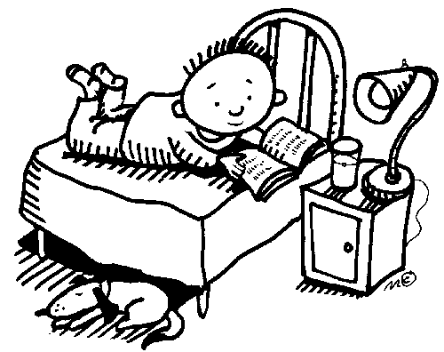

Homework Policy
Dear Parents,
Homework is an important part of your child’s first grade experience. Supporting good work habits requires a joint effort. I will support your child and encourage good work habits at school. Your child will benefit greatly from your support and encouragement at home.
Please read the homework policy below and explain it to your child.
- Each child will receive a Homework Folder that they will bring home each night. Throughout the year, I will be sending home important papers in the homework folder. It is the parent’s responsibility to check the homework folder daily for important notes, tests, reminders, etc.

- As part of homework, your child is required to READ for at least 15 minutes every night. Please make sure you are helping your child log their reading every night. The reading log should always be placed in the “Reading Log” section of their homework folder. Reading logs will be given out at the beginning of every week and your child will be expected to fill it out each night and hand it in at the beginning of the following week.

- It is also very important that your child continues the reading practices that are being learned at school, at home. Therefore, each night your child will be allowed to bring home up to 3 leveled books from their very own school reading bin. This way they will be able to read and practice at home exactly what they’re reading in school.

- Homework will be assigned EVERY DAY except Fridays. Please take note that sometimes we will be working on a certain project that will require some weekend homework.

- All homework assignments, except the Word Work packet, are due the day after they are given. Word Work packets will be given on Monday and will be collected on Fridays.

- Most homework will be checked and returned so that you can review with your child any mistakes they’ve made in their homework throughout the week. Some homework assignments will be used as part of our daily math lessons. Use the chart below to understand homework grading:
- A happy face means all homework was done correctly.

- - A check means that the homework was checked, but 1 or more answers were incorrect

