Class 1-210 - Current Units of Study
Reading – This month students will be learning the routines and structures of first grade reading. The students will be learning strategies to help them decode and understand the books they are reading.

Writing – This month we will be writing Small Moment stories. In this writing genre, students will write personal narrative stories from their lives. In addition, they will learn how to add more details to their words and pictures in order to make their writing stronger.

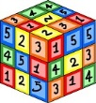 Math – Our math lessons for this month will consist of some review of counting skills, as well as, beginning addition concepts. The students will be engaged in using hands on manipulatives to practice representing numbers and equations.

Social Studies - The beginning of the year is the best time for our students to get to know each other and learn ways to work best within our classroom community. In our first unit of social studies we will be working on community building and learning ways to problem solve peacefully.

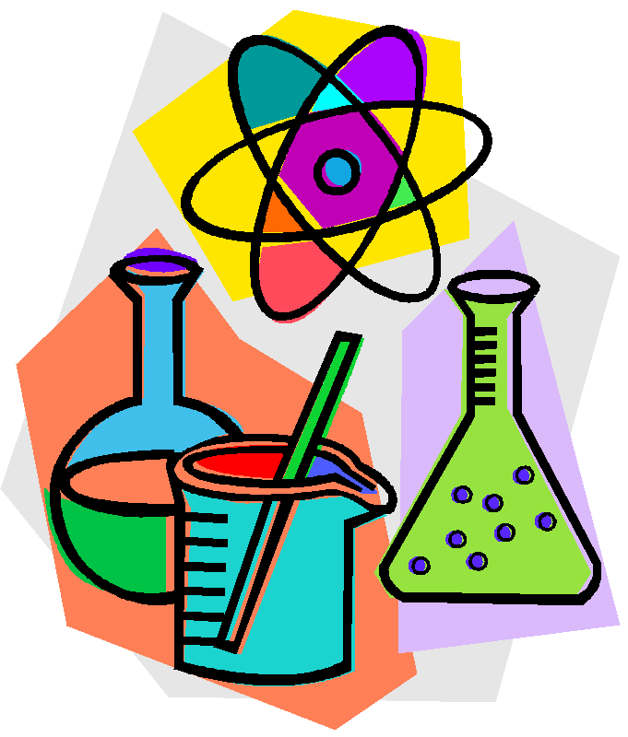 Science – We will soon begin our unit on the Fall Season!

